FOCP C Programming Assignment
Module 3: Loops
Question 2: Number of Steps to Reduce a Number to Zero
Platform: LeetCode
Programming Language: C
Problem Link: https://leetcode.com/problems/number-of-steps-to-reduce-a-number-to-zero/
Problem Statement
Given an integer num, return the number of steps required to reduce it to zero.
In each step:
- If the current number is even, divide it by 2.
- If the current number is odd, subtract 1 from it.
Repeat these steps until the number becomes zero.
Examples
Example 1:
Input: num = 14
Output: 6
Explanation: 14 → 7 → 6 → 3 → 2 → 1 → 0
Example 2:
Input: num = 8
Output: 4
Explanation: 8 → 4 → 2 → 1 → 0
Example 3:
Input: num = 123
Output: 12
Constraints
- 0 <= num <= 10^6
Source Code
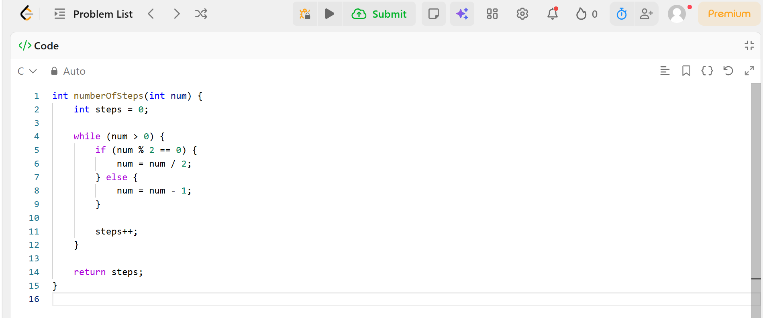
Output
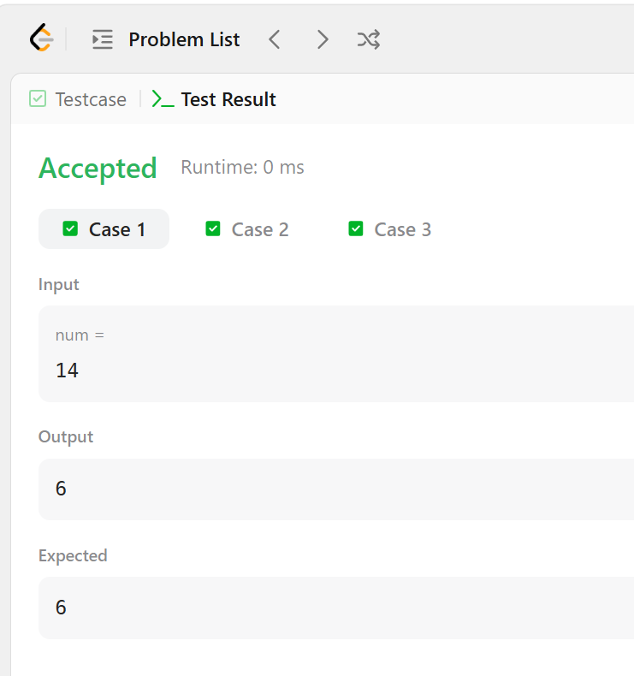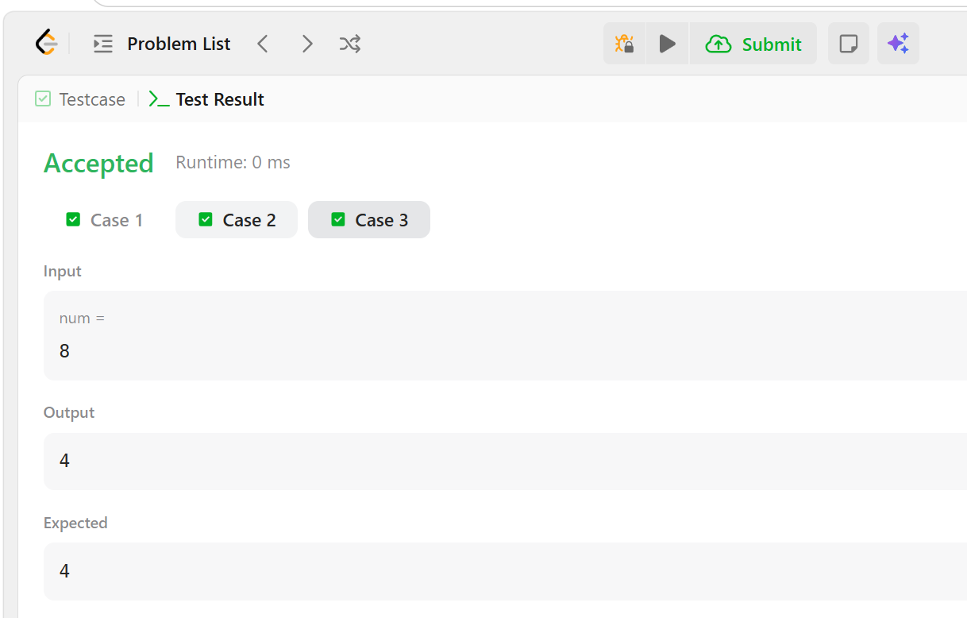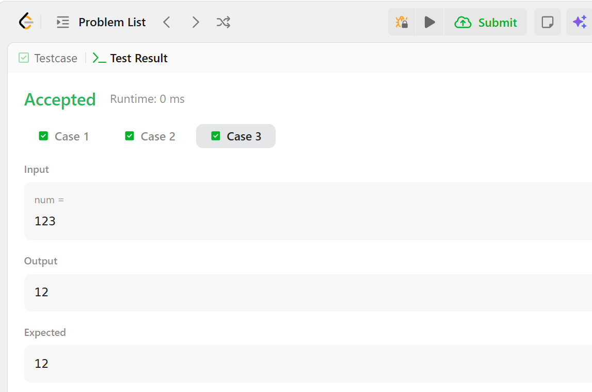
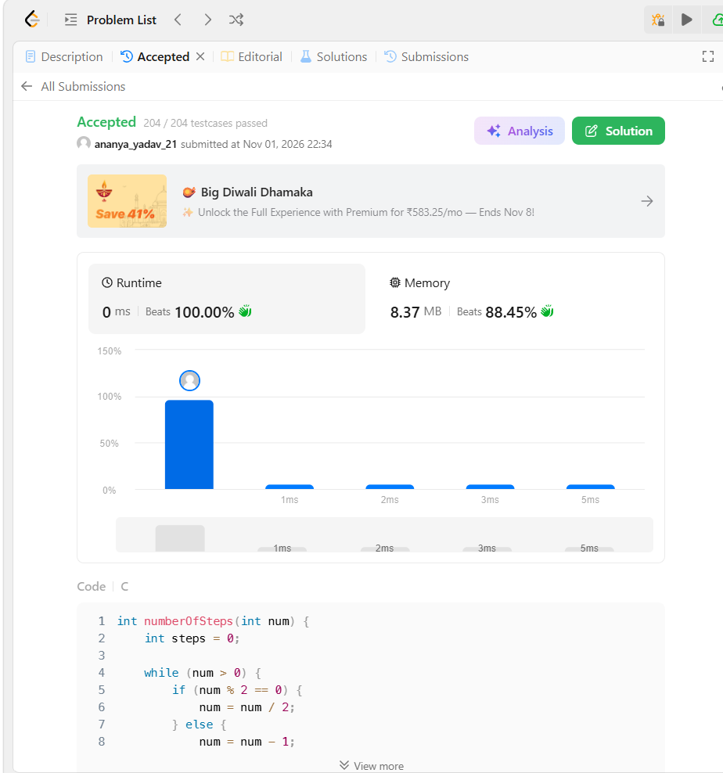Result
The program was executed successfully, and all test cases were passed on LeetCode.

